

### “The MPC and the UK Economy: Should we fear the D-words?”

Speech given by

Charles Bean, Chief Economist, Bank of England

To the Emmanuel Society in London 25 November 2002

1

All speeches are available online at [www.bankofengland.co.uk/publications/Pages/speeches/default.aspx](http://www.bankofengland.co.uk/publications/Pages/speeches/default.aspx)

Good evening. In my talk tonight I want to start by giving a thumbnail sketch of how the MPC sees the economy evolving in the next year or two. But I will focus the bulk of my talk on a couple of issues that have been absorbing rather a lot of newsprint in recent weeks: Deflation; and Debt.

##### The current conjuncture

Given the slowdown in global activity over the last two years, the UK economy has not been doing too badly. Growth was the highest among the G7 economies last year. And after stagnating around the turn of the year, growth has picked up to around its trend rate in the second and third quarters. Unemployment is only fractionally higher than at its trough in May last year. And though RPIX inflation has been running a little below 2½% for much of the past year, it is now moving back up towards the target.

But the picture is more complex when one scratches below the surface, as conditions have differed greatly across sectors. Against a background of intensified global competition, slowing world activity and a weak euro, manufacturing has been struggling. Manufacturing output rose in the third quarter, but that followed six consecutive quarters of contraction. Moreover, the pattern in the official data has been distorted by the Jubilee holidays, and the underlying trend appears to have been little better than flat since the first quarter. On the other hand, businesses in the service sector, taken as a whole at least, have experienced underlying growth at close-to-trend rates. This is reflected in their respective profit rates: in the second quarter the rate of return on capital in manufacturing was just 4%, while that in services was 14%.

What lies behind this difference in sectoral fortunes? In essence it reflects the uneven pattern of demand growth in the UK economy. Annual household spending growth has averaged nearly 4¼% a year since 1996, while total UK domestic demand has grown at an average rate of more than 3½%. That is somewhat higher than both the actual and trend rate of growth of output. In fact domestic demand has grown faster than output in each of the last six years, the first time this has happened since the 1870s. But the rapid growth in domestic spending has not fuelled higher inflation, because the relative strength of sterling has helped to hold down the price of imports,

boosted the volume of imports and retarded exports. And that has been associated with a persistent, though not excessively large, deficit on the current account of the balance of payments. In essence, domestic demand has been heating the economy up, while external demand has been cooling it down.

Now just as I can spend more than I earn by borrowing, but cannot keep doing so indefinitely - to repay the debt either my income will need to rise or else I will have to cut my spending - so the same is true for nations. At some stage UK domestic demand growth will have to slow to around, or below, the rate of growth of output. That could well be associated with some falling back of the exchange rate, which would help to redress the divergence between manufacturing and services. But the longer the imbalances persist, and the larger the divergence becomes, the more difficult that eventual adjustment may prove.

Furthermore, the imbalances have become starker during the global slowdown, which has impinged most heavily on businesses that produce for export. The MPC has deliberately sought to compensate for the disinflationary implications of the global slowdown by reducing interest rates in 2001 and keeping them at historically low levels through this year. The primary consequence has been to boost consumer spending and domestic demand even further.

What are the prospects going forward? The MPC’s most recent forecasts, conditional on interest rates remaining at their current level of 4%, were contained in the Bank’s November *Inflation Report.* Our central projection is for a continuation of growth at close-to-trend rates over the next two years. That is sustained in the near term by continued buoyancy in household spending. Further down the road, some slowing on the consumer side is projected, but that is offset by increased public sector spending, a recovery in external demand and a modest pick up in business investment.

Annual RPIX inflation is expected to move above the target by the year-end, because of the effect of higher house prices on the part of the index that captures housing depreciation and as sharp falls in petrol prices a year ago drop out. These effects are likely to be temporary, so that inflation may then drop back a little bit below the target

in around a year’s time. The big picture is one of underlying inflation continuing to run fairly close to the 2½% target.

But there is a lot of uncertainty about future developments – something we seek to emphasise by always presenting our projections in the form of probability distributions rather than point forecasts. There are many risks to the outlook, but in the rest of this talk I want to focus on two of these: the risk of deflation; and the problems posed by the accumulation of household debt.

##### The threat of deflation

Although recent performance has been patchy, our central expectation in the *Inflation Report* is that the world recovery will gradually pick up steam. But to some commentators this is altogether too rosy a view, for they see deflation as a serious threat to the world economy. Japan has already experienced falling consumer prices for most of the last four years, and some see the United States and Germany as being in danger of going the same way. Even the United Kingdom is talked about as a candidate for the deflationary club, given that retail goods price inflation has been close to, or below, zero for the past year.

So is there a threat of deflation? And if there is, should we be worried about it? Some of you may be old enough to remember Professor Cyril Joad of the BBC’s *Brains Trust*, who would no doubt have declared: “It all depends what you mean by deflation”. At its simplest, deflation is a sustained period over which the general price level is falling. But just as there are many different strains of influenza, some of them lethal, and some of them producing just temporary discomfort, so it is with deflation. And just as a bad cold may generate 'flu-like symptoms, so economies may exhibit some of the symptoms of deflation without necessarily suffering from the virus.

##### Deflation in the Thirties

How might a sustained period of falling prices come about? And why might it be a problem? A good place to start is with the Great Depression, probably the best-known example of the deflationary process in action. The tail end of the Roaring Twenties

was marked by a booming stock market and abnormally high levels of investment, especially in real estate. But demand began to slow during 1929, culminating in the stock market crash. The depression that followed was extreme in its magnitude.

Between 1929 and 1933, output in the United States fell by nearly a third, while the price level fell by nearly a quarter (see Chart 1).

According to the conventional wisdom of the time, such systematic under-utilisation of resources could result from the exercise of monopoly power in product or labour markets – in other words constraints on supply - but not from a lack of overall demand. Keynes’ great insight was that there were circumstances in which demand drove supply, and not the other way round. A fall in demand, say because of lower investment, could lead to lower output and incomes, reducing consumer spending and output yet further. But the puzzle is not why there was a downturn after the excesses of the Twenties and the stock market crash of 1929. Rather why was the slump so great?

Part of the reason was the amplifying role played by falling prices. Now nominal interest rates can never be negative, as if they were then people would just prefer to hold cash instead1; there is thus a natural zero lower bound to interest rates.

Consequently even if nominal short-term interest rates are cut to the bone, real interest rates will still be positive if inflation is negative. And it is real interest rates that determine the level of demand. The essential feature of a deflationary trap is thus that the real interest rate is unable to fall to the level necessary to keep demand in the economy in line with supply. Chart 2 illustrates this graphically: even though the US Federal Reserve did cut short-term nominal interest rates during the 1929-33 downturn, *real* interest rates rose sharply.

Furthermore, deflation that is unanticipated increases the real value of any debt that is denominated in nominal terms. It therefore redistributes wealth from debtor to creditor. The "unanticipated" qualification is important because, if the deflation had been anticipated, then the borrower would have expected to pay a lower nominal interest rate to compensate. If, as seems likely, debtors have a higher propensity to

1 Technically money could pay negative interest, if it had to be exchanged periodically for new money at which time a fraction was also confiscated. This suggestion is originally due to Gesell.

consume out of their wealth, then unanticipated deflation will tend to reduce overall demand2. Moreover, increasing real debt burdens juxtaposed against falling activity is likely to lead to insolvencies and worsening bank balance sheets. In the 1930s this led to bank failures, bank runs and a breakdown in the process of financial intermediation3.

##### Will history repeat itself?

The experience of the United States in 1929-33 illustrates pretty graphically why policy makers should fear deflation. What are the chances of a recurrence today?

*Japan*

To some extent history has already repeated itself in Japan, where consumer prices have been falling for much of the last four years and short-term nominal interest rates are, to all intents and purposes, zero. But it is worth pointing out that Japan’s problems pale into insignificance compared with the inter-war US experience.

Outright contraction was experienced in just 1998 and 2001 and even then the falls in activity appear to have been relatively mild (Chart 3). Consumer prices in Japan are today just 3% lower than at their peak, and real interest rates are still at relatively low levels (Chart 4). This is not (yet, at least) a vicious deflationary spiral of the inter-war variety, but rather a picture of relative stagnation.

Moreover, while the ability to achieve lower real interest rates would no doubt have helped to boost demand and activity, Japan’s problems stem from the legacy of the eighties' boom in equity and land prices and the associated over-investment. The by- product has been a build-up of non-performing loans in the financial sector. Restoring the full effectiveness of monetary policy in Japan depends to a significant extent on seeing through the necessary writing down of such debts, together with an appropriate

2 The mechanism at work here applies more generally to any change in real indebtedness, whether brought about through changes in the price level or otherwise, and is sometimes referred to as “debt deflation”. See M A King, “Debt deflation: theory and evidence”, European Economic Review, 1994, for a fuller discussion.

3 See B Bernanke, “Non-monetary effects of the financial crisis in the propagation of the Great Depression”, American Economic Review, 1983, for a discussion of the role of financial collapse in the Great Depression.

restructuring of both the financial sector and the real economy. But as much as anything, the economic stagnation in Japan reflects the difficulty of reaching a political agreement about how to tackle Japan’s economic problems and who will bear the associated burden, rather than the ineffectiveness of economic policy *per se*.

*United States*

Today it is the United States that, on the surface at least, bears the most obvious similarities to the United States in 1930 and to Japan in 1990. As in those cases, a stock market boom was followed by a subsequent correction. Furthermore the boom period was associated with relatively high rates of corporate investment and household spending.

As in the 1920s, the driver during the period of “exuberance” was optimism about the future. In the case of the United States at the end of the 20th century that was fostered by the pick up in trend productivity growth associated with the exploitation of information and communication technology. Now the rational response to a sustained increase in productivity growth is to increase both investment (to take advantage of the higher productivity of capital) and consumption (to take advantage of higher expected future incomes). In an open economy the consequence will be a deterioration in the current account of the balance of payments. That is exactly what we saw in the United States.

The correction to equity markets since their peak in the middle of 2000 has highlighted the extent to which those expectations were overly optimistic, at least in the corporate sector, and the consequence of the downward revision to earnings expectations has been a sharp decline in investment. The downturn has so far been relatively mild as consumer spending has held up better than would normally have been the case. A continuation of the current rates of consumer spending requires households to remain relatively optimistic about the future - and the fact that productivity growth has held up well through the slowdown is a positive sign. But *if* households were to revise their expectations down markedly, then a sharp deceleration in household spending would result. The fraction of household income that is saved in the United States is still just 4% as compared to its historical average

of nearer 8%. A sharp return to historical norms could potentially provide the shock necessary to push the economy into deflation.

There are a number of reasons why a move into deflation is unlikely, though not impossible. First, consumer price inflation is still comfortably positive at 2.1% in October. With the official interest rate now down to 1.25%, the short-term real interest rate is now in negative territory and monetary policy is strongly expansionary. And although nominal interest rates are low, the Federal Reserve still has some further room for manoeuvre. Moreover, as indicated in the January 2002 minutes, the Federal Open Market Committee has shown that it is aware of the dangers of deflation and prepared to countenance unorthodox measures if necessary (what these might be are discussed briefly below). In addition fiscal policy is expansionary, and may well become more so. Finally, it is likely that there would be greater transparency about the existence of any non-performing loans, encouraging a faster writing down of such loans and more rapid re-structuring of enterprises than has been the case in Japan.

*Germany*

Some commentators suggest that Germany is also a candidate for the slide into deflation. Consumer price inflation is just over 1% and growth has been lacklustre; it seems that it would not take much to push inflation into negative territory. But this is a case where the symptoms could prompt an incorrect diagnosis. Inflation in the euro area as a whole is currently still a little above the 2% ceiling of the range that the European Central Bank regard as consistent with price stability. The counterpart to low inflation in Germany is higher inflation elsewhere: currently around 4% in Greece, Ireland, Netherlands, Portugal and Spain. But within a monetary union, any required change in regional relative prices necessarily must occur through differences in inflation rates. The relatively low inflation in Germany is simply the natural working out of such an adjustment process.

There are at least two reasons why Germany should be inflating less quickly than are her neighbours. First, monetary union arguably commenced with a somewhat overvalued German real exchange rate, relative to the other members of the euro area. Since reunification, German annual growth has averaged just 1.4% compared to 2.2%

for the rest of the euro area. That relatively weak growth performance in part reflects relatively high labour costs: according to the ILO, hourly labour costs in manufacturing in 2001 were roughly 45% higher than in France and 66% higher than in Italy. But these cost differences are not reflected in higher productivity: GDP per hour in 2001 was actually about 10% lower than in France and Italy. Although international comparisons are hazardous, these cost differences are reflected in relatively low German profitability - in fact the lowest in the G7 in 2000, the latest year for which data are available for a wide set of countries4. These are all symptomatic of an economy with an overvalued real exchange rate, stemming originally from the task of absorbing the eastern Länder, with their relatively low productivity. And in a monetary union such a misalignment of relative prices gets corrected through a temporary divergence in inflation rates, rather than through a change in the nominal exchange rate.

Second, the poorer countries of a monetary union should in any case exhibit faster consumer price inflation as living standards catch up with those in richer ones.

Suppose that there is a single integrated market, and therefore a single price, for internationally traded goods (think of them as manufactures). Now the more rapid productivity growth in the countries that are catching up will also be associated with a higher rate of growth in the demand for goods that are not traded internationally (think of them as services). Consequently the relative price of services to manufactures must rise more in the high productivity growth country (this is known as the “Balassa-Samuelson effect”). It follows that inflation is also higher in the high productivity growth country.

There have been attempts to evaluate the likely size of this effect. For the present membership the maximum annual inflation differential is likely to be of the order of 2%-2.5%5. This is pretty much the same as the current inflation differential between Germany on the one hand and the four recipients of the Cohesion funds on the other.

4 See L Citron and R Walton, “International comparisons of company profitability”, Economic Trends, October 2002.

5 See e.g. M Canzoneri, R Cumby, B Diba and G Eudey “Productivity trends in Europe: Implications for real exchange rates, real interest rates and inflation differentials”, forthcoming in Review of

International Economics. Similar estimates appear in the European Commission's own economic analysis of monetary union, One Market, One Money.

Thus if the European Central Bank maintained inflation around, say, 2%, Germany, as one of the highest productivity countries in the euro area, should expect to experience an average inflation rate of around 1% so long as other countries in the monetary union are catching up.

So to summarise: Germany may be seeing low inflation - and may well experience falling prices - but that is part of a necessary and natural adjustment in relative prices within the euro area, not a deflationary spiral.

*United Kingdom*

A few commentators have also suggested that the United Kingdom is a suitable candidate for deflation, citing the fact that the price of manufactured goods is already falling and arguing that other prices will soon follow suit. Thus in October, retail goods prices were down 0.7% on a year earlier. But the counterpart to falling retail goods prices is rapid inflation in the price of retail services: up 4.8% in the year to October (Chart 5).

Now some divergence between the rate of increase in goods prices and the rate of increase in services prices is to be expected, as productivity typically rises 1½-2% points faster in manufacturing than in the service sector. Given that pay tends to rise at roughly the same rate across all industries, that implies prices should tend to rise, on average, about 1½-2% points faster in services. And that has indeed tended to be the case over the past, although there have been periods where the gap has sometimes been a bit smaller or a bit bigger than this. Moreover, this is a phenomenon that is common to the United States and other developed economies (Chart 6).

What is unusual is the size of the current gap in inflation rates, which is too big to be purely the result of sectoral productivity differences. Now the price falls have been concentrated in three sectors: clothing and footwear; leisure goods (which importantly includes audio-visual equipment); and motor vehicles. But the share of nominal consumer spending on these three categories is actually slightly higher today than it was in 1996, and that at a time when overall consumer spending has been rising rapidly. So an overall lack of demand for these particular products is not the problem.

It is noticeable is that global competition has been particularly important in all three industries. What we are witnessing is the working out of the principle of comparative advantage as the developing and industrialising economies with access to relatively cheap labour displace labour-intensive domestic producers, while the United Kingdom moves into more skill-intensive manufacturing and tradeable services. And the downward pressure on prices in the labour-intensive tradable sectors will have been intensified by the strength of sterling.

Once again what appears to be deflation is really better thought of as an adjustment to relative prices. Just as low inflation in Germany should be seen as regional relative price adjustment across the euro area as a whole, so the low rate of UK goods price inflation is part of a process of sectoral relative price adjustment.

##### Policies to deal with deflation

It should be apparent now that deflation can come in a variety of forms, some of which should be of more concern than others. But policy makers need to be alive to the dangers of the most virulent form of the disease. And as with any disease, prevention is better than cure.

What policies are available? First, and probably foremost, inflation has been close to the 2½% target. As a consequence inflation expectations, in both financial markets and those held by the public, have also become entrenched around the 2½% level.

That means that any decline in inflation need not be immediately reflected in either *expected* real interest rates or in wage settlements. That will help to retard any potential slide into inflation in the face of an adverse demand shock. Moreover, if consumer price inflation did start to fall below target, the MPC could be expected to take action by further reducing interest rates in order to bring inflation back to the target.

Furthermore, in the unlikely event that short-term official rates did reach their lower bound of zero, monetary policy would not become totally impotent. The Bank of England operates primarily through short-term lending against eligible collateral

(known as repurchase agreements, or repos). The interest rate at which the Bank conducts these operations then directly influences short-term market interest rates. Frequently it is longer-term interest rates that matter more to private agents, but they in turn are heavily dependent on expected future short-term interest rates. So committing to keep future short-term official rates at zero should help to drive down longer-term interest rates as well. If necessary this could be complemented by outright purchases of longer-term government securities, or even *in extremis* operations in corporate debt and equity. Furthermore the resulting increase in liquidity may have the effect of raising inflation expectations, thus interrupting the deflationary cycle.

Finally – as recommended by Keynes – fiscal policy could play a role in boosting demand. The Chancellor’s fiscal rules, which require that the budget deficit on current account balance over the cycle and public sector net debt be maintained at a prudent level, permit the operation of the automatic fiscal stabilisers in full as well as leaving scope for appropriate additional discretionary fiscal action if that were necessary.

##### Household debt and house prices

The second issue I wish to discuss relates to the behaviour of the UK consumer. As I mentioned at the outset, one key aspect of the imbalances in the UK economy has been the buoyancy of household spending which has consistently grown faster than output over the last six years. And associated with that has been a build-up of household debt and rapid house price inflation. The MPC has been grappling with how to assess the potential problems that these factors could pose to the economic outlook going forward.

In addressing this question, it is helpful to ask why consumer demand has been so buoyant in the first place. Standard economic theory suggests that it should be “permanent” income – in essence the average expected income over one’s lifetime - rather than current income that drives consumer spending. If future income is expected to be higher than today’s income, households tend to borrow in order to boost consumption today. And if they expect income to drop in the future, they tend to save more in order to maintain their consumption levels tomorrow. But the extent

to which they will shift consumption backwards or forwards in time will also depend on the cost of borrowing and the return to saving.

Now the recent strong growth in consumption has coincided with strong growth in real disposable household incomes and falling unemployment, and for a while also with rising equity prices (I will come to the role of house prices later). So one explanation is that households have been revising up their assessment of their permanent income. But a significant fraction of the increase in real household incomes has been associated with the substantial improvement in the terms of trade – up 12% since 1996. An important issue is whether the improvement from this source is permanent, reflecting the exploitation of comparative advantage, or whether it is associated instead with a temporarily high level of the exchange rate, in which case real incomes and consumption will eventually both drop back.

To the extent that there has indeed been an increase in households’ permanent income, then we would expect consumption growth in due course to fall back in line – or strictly speaking a little below – the rate of growth of their income, with the extra accumulated debt being gradually repaid. But if expectations prove to be over- optimistic then a sharper future correction to consumer spending is likely.

A second explanation for the rapid growth in consumer spending and debt is easier access to, or cheaper, borrowing. This is where house prices enter the picture. Now unless I am expecting to trade down to a cheaper property, a rise in house prices does not make me as an owner-occupier any better off. So housing does not represent household wealth in quite the same way as equities do. But housing does represent collateral against which I can borrow. So the higher house prices of recent years have allowed owner-occupiers to increase their borrowing, using the proceeds in part to boost spending.

But why has the price of houses risen? The demand for housing services should be driven by the same factors that drive the demand for consumer goods and services, i.e., permanent income. Chart 7 shows the evolution of house prices relative to the nominal value of consumer spending per household (a proxy for consumers’ estimates

of their permanent income). That ratio has risen sharply in recent years, although the picture is not quite as dramatic as when house prices are compared with earnings.

So something else has also been driving house prices, and the value of the collateral against which owner-occupiers can borrow. There are at least three reasons why the demand for housing might have risen more than might be suggested simply by looking at permanent income.

First, the transition to an environment of low and stable inflation implies that nominal interest rates should be lower on average than they have been in the past. Standard mortgages usually entail an even level of nominal payments (interest plus repayment of principal) over the life of the mortgage. Consequently the initial *real* payments for a given nominal debt will be smaller than they would be if inflation and interest rates were high, though the real burden of payments towards the end of the loan period will conversely be somewhat greater. Shifting the pattern of real payments into the future in this way makes households that are constrained by their cash flow more willing or able to borrow, thus driving up the demand for housing. But a concern is that borrowers may not yet have fully factored in the fact that the share of future income taken up by mortgage payments will be higher now that inflation is low.

Second, increased competition amongst lenders and the application of better credit scoring techniques may also have increased the supply of loans. And third, population growth and demographic developments – more people wanting to live alone and an increased desire for second homes – will also have boosted demand.

In addition, on the supply side of the market the rate of construction of new dwellings has lagged behind the expansion in the number of households, in part because of a shortage of land and the impact of planning restrictions. This is indicated in Chart 8 which shows the ratio of dwellings to households – a measure of spare capacity in the housing market - has been steadily falling over the last two decades.

So there are reasons why a higher house-prices-to-consumption ratio (or house-prices- to-earnings ratio) might be warranted by underlying economic developments. But it should be recognised that there are factors that work in the opposite direction: the tax

advantages of owner-occupation are lower in a low inflation environment; and housing loses its advantage as a hedge against inflation. So it has to be acknowledged that there is very considerable uncertainty about all of this.

Our central expectation is that the rate of increase of house prices will slow sharply over the next year, with prices becoming broadly stable in two year's time. And if that happens consumption growth should slow too, although the presence of some unexploited housing collateral may mean that slowdown will only follow with a lag.

But this is not a view we hold with great confidence, and there are risks on either side. We have been consistently surprised by the strength of house price inflation over the last year, and in the near term there is a possibility that house price inflation may continue to exceed our expectations. That would put upward pressure on demand and inflation in the short term, other things equal. But against that, the longer current rates of house price inflation persist the greater the likelihood of a subsequent sharp correction.

The MPC’s strategy during the slowdown has been to offset the weakness of external demand by boosting consumer demand through lower interest rates. What light does the above discussion shed on the dangers of this strategy? In particular should we be worried about encouraging households to build up more debt?

The sanguine view is that all that has happened is that lower real interest rates have encouraged households rationally to shift spending from the future to the present by increasing their borrowing. The counterpart to this will be somewhat lower growth in spending in the future, but there is no particular reason for this to occur in abrupt fashion. And if necessary we could go on encouraging this intertemporal substitution of spending by further reducing rates until such time as nominal interest rates reach the zero lower bound.

But high debt levels may also increase the impact on consumer spending of an adverse shock, such as a delayed recovery in the world economy that leads to higher unemployment. Households with adequate liquid assets or who can still access the credit market would not need to cut back their consumption much if they experience a

spell of unemployment (I am assuming the spell without a job does not harm their future earning potential). Instead they simply run down their savings or borrow more. On the other hand, households with no assets, and who cannot borrow more, would be forced to cut back their spending in line with their reduced income, net of any repayments on outstanding debt. So the impact of this adverse shock on aggregate consumption will be greater, the higher is the fraction of constrained households.

Furthermore that fraction will tend to be higher, the greater is the amount of debt already extended.

So a key question is whether those who hold the debt are particularly likely to be exposed to adverse shocks, such as job loss, and whether they have other assets that they could run down. The good news is that it is those households who hold the most debt also tend to have higher income and more assets (see Chart 9). This is not very surprising as most of the debt is in the form of mortgages and typically bigger mortgages are associated with more expensive houses!

Perhaps more relevant in assessing the potential vulnerability of the household sector to shocks is the matching of debts to liquid assets. Here the news is not quite so good. Chart 10 illustrates the distribution of total liabilities and liquid assets across individual households, drawn from a 10% random sample of the 5,000 households in the 2000 British Household Panel Survey. A large number of households are positioned on one or other axis: 40% had no liabilities and 33% no liquid assets. This suggests that the financial position of the household sector is rather less resilient that might be suggested by merely looking at aggregate balance sheet data.

How should all this affect the conduct of monetary policy? In the Committee's central projection, the imbalances in the economy correct themselves relatively smoothly over time. But as already explained, the build-up of debt would potentially aggravate the impact of any adverse shock, such as a delay to global economic recovery. We would presumably seek to offset the disinflationary impact of such a shock by lowering interest rates. That would reduce the debt service required of indebted households - indeed the higher debt levels would actually make monetary policy more potent than usual. But any deterioration in employment prospects might encourage precautionary saving by presently unconstrained households who feared the prospect

of job loss, and also lead to a tightening of credit conditions if lenders became more concerned about bad debts. There could, as a consequence, be considerable uncertainty about the dosage required.

So boosting demand today may raise the likelihood of a sharper, or at least more unpredictable, fall in spending at some stage in the future. Consequently, if one starts with inflation below the target, there may be something of a trade-off between getting back to the target in the near term, and staying close to it further out. Quantifying the importance of this argument requires further work, however.

##### Concluding remarks

I hope that my talk tonight has persuaded you that some of the more alarmist commentary about the threat of global deflation is over done. Although Japan is already experiencing falling prices with zero interest rates, it is still a long way from falling into the sort of cumulative deflationary spiral that characterised the United States during the Great Depression. And while a sharp contraction in consumer spending would pose a threat to the US recovery, there are good reasons for believing that the US economy is unlikely to follow Japan into deflation.

As for Germany, low inflation there is better thought of as part of a process of regional relative price adjustment in the context of monetary union, rather than the beginnings of a classic deflationary process. And a similar argument applies in respect of the low rate of goods price inflation in the United Kingdom – again it represents part of a process of relative price adjustment rather than general price deflation. But while these are reasons to discount some of the more alarmist commentary, it is important that we, and other central banks, are alive to the possibility of deflation however remote that may be, and stand ready to act pre-emptively if warranted. After all, the minor discomfort of inoculation against the ‘flu beats a week of suffering any day!

The build up of consumer debt does, however, present us on the MPC with a more immediate threat. Our central expectation is that the growth in consumer spending will ease back over the next year or two and the rate of increase in house prices will

slow markedly. But it is possible that we may continue to be surprised on the upside in the near term, which raises the possibility of sharper adjustment in the future. So there are upside risks in the near term, but downside risks further out. And the continuing build-up of household debt makes consumer spending more vulnerable to adverse shocks, and with it the outlook for inflation. But, as ever, the Committee will stand ready to act in order to ensure that the UK’s recent relatively satisfactory macroeconomic performance continues for a while longer.

# Chart 1

Growth, Unemployment & Inflation: US, 1929-40

**30**

**20**

**10**

**Per Cent**

**0**

**-10**

**-20**

**1929 1930 1931 1932 1933 1934 1935 1936 1937 1938 1939 1940**

**Inflation Growth Unemployment**

Chart 1:

Source: Historical Statistics of the United States, Colonial Times to 1970, Parts I and II (Washington, DC: US Department of Commerce, Bureau of the Census, 1975).

**Chart 2**

Nominal & Real Interest Rates: US, 1929-40

**15**

**10**

**5**

**Per Cent**

**0**

**-5**

**-10**

**1929 1930 1931 1932 1933 1934 1935 1936 1937 1938 1939 1940**

### Interest Rate Real Interest Rate

Chart 2:

Source: Historical Statistics of the United States, Colonial Times to 1970, Parts I and II (Washington, DC: US Department of Commerce, Bureau of the Census, 1975).

**Chart 3**

**Growth, Unemployment and Inflation:**

**Japan 1990 to now** Percentage change on year earlier

8.0

GDP growth

Inflation (NSA)

Unemployment

6.0

4.0

2.0

1990 1992 1994 1996 1998 2000 2002

0.0

-2.0

-4.0

Chart 3:

Source: Japanese Cabinet Office, Statistics Bureau, and Ministry of Public Management, Home Affairs, Posts and Telecommunications.

**Chart 4**

**Nominal & Real Interest Rates: Japan 1990 to now**

Percent

10

8

Interest rate

6

Real Interest rate (NSA)

4

2

0

-2

1990 1992 1994 1996 1998 2000 2002

**Chart 4:**

**Source: OECD**

**Chart 5**

**RPIX goods and services**

Percentage change on a year earlier

**12**



**RPIX services**

**RPIX**

**RPIX goods**

**11**

**10**

**9**

**8**

**7**

**6**

**5**

**4**

**3**

**2**

**1**

**0**

**-1**

**-2**

**1987 1990 1993 1996 1999 2002**

Chart 5:

Source: ONS

**Chart 6**

**The gap between annual retail service**

**inflation and retail goods inflation**

**(a)**

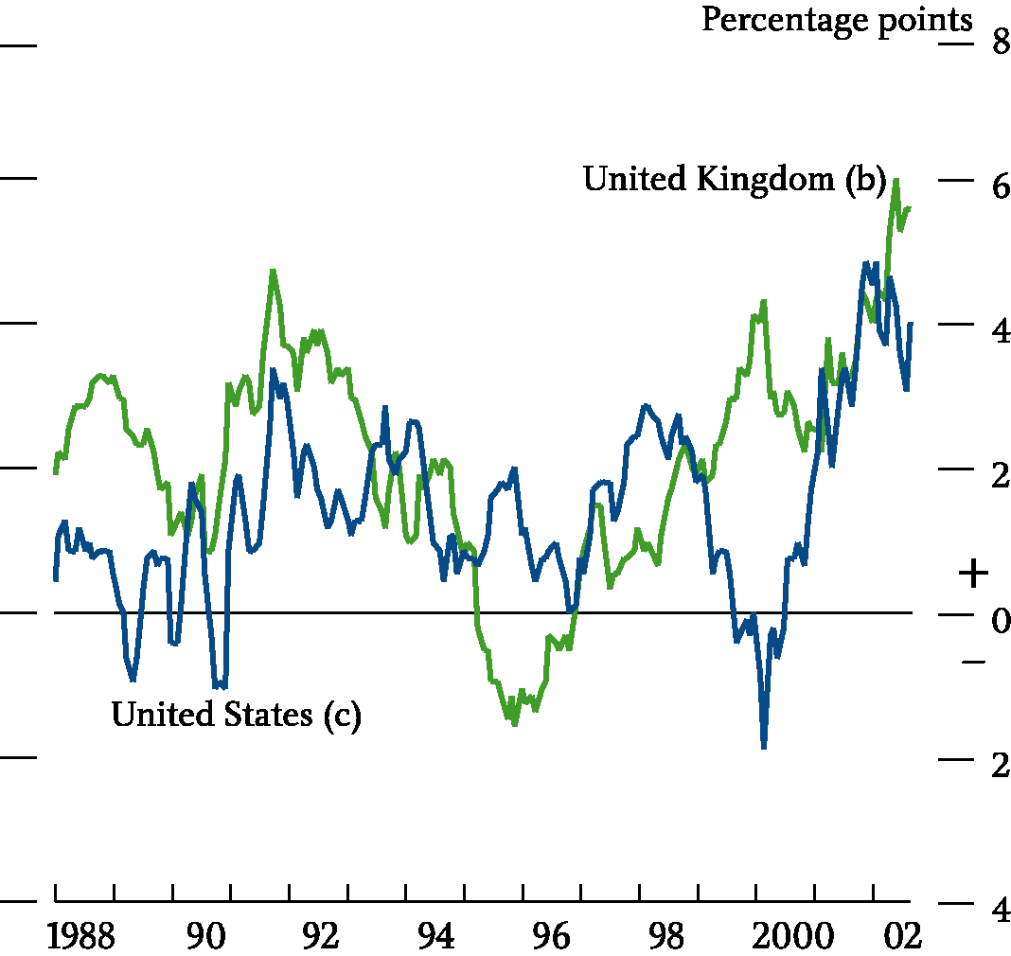

Chart 6:

Sources: ONS and US Bureau of Labor Statistics.

1. Defined as retail services inflation minus retail goods inflation.
2. RPIX inflation.
3. CPI inflation.

**Chart 7**

### House price to nominal consumption per household ratio and house price to earnings

#### 150

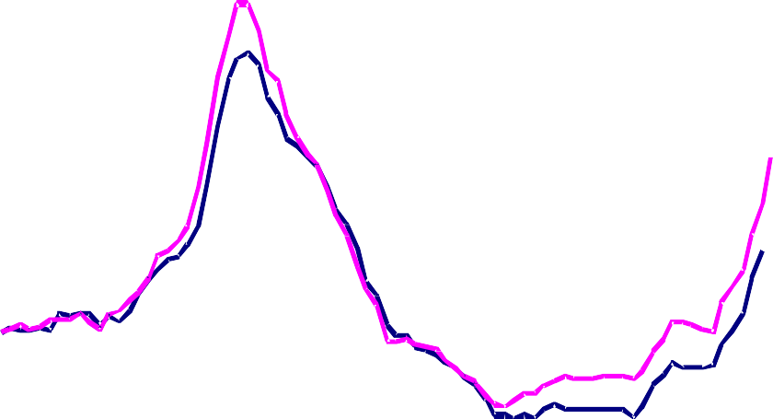

**ratio**

Index: 1983Q1= 100

House price to earnings

House price to nominal consumption

per household

140

130

120

110

100

90

80

70

60

1983 1986 1989 1992 1995 1998 2001

Chart 7:

Sources: Halifax, Office of the Deputy Prime Minister, ONS and Bank of England

**Chart 8**

**Ratio of dwellings to households**

(a)

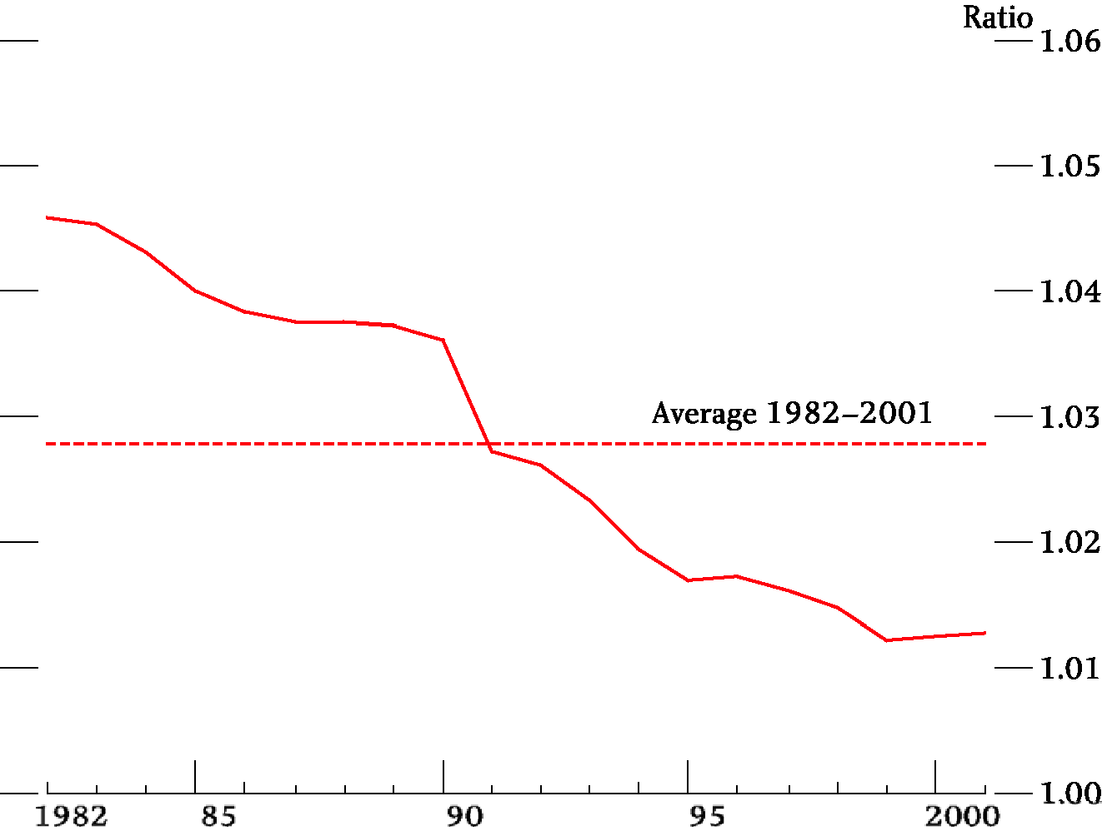

## Chart 8:

Source: Office of the Deputy Prime Minister.

1. Figures for the stock of dwellings are for 31 December each year prior to 1991 and 31 March from 1991 onwards. This may account for most of the fall in the ratio in 1991.

**Chart 9**

**Average financial assets, housing wealth and debt at different levels of household indebtedness (2000)**

#### Financial assets Housing wealth Total debt

£ thousands 200

180

160

140

120

100

80

60

40

20

0

5-10k

10-15k

15-25k

25-35k

35-45k

45-55k

55-65k

65-75k

75k+

Household total gross debt (£)

Sources: BHPS and Bank calculations.

0

1-500

500-1000

1-5k

Chart 9:

Sources: British Household Panel Survey and Bank calculations.

**Chart 10**

Chart 10:

**Distribution of total liabilities and liquid assets across individual households**

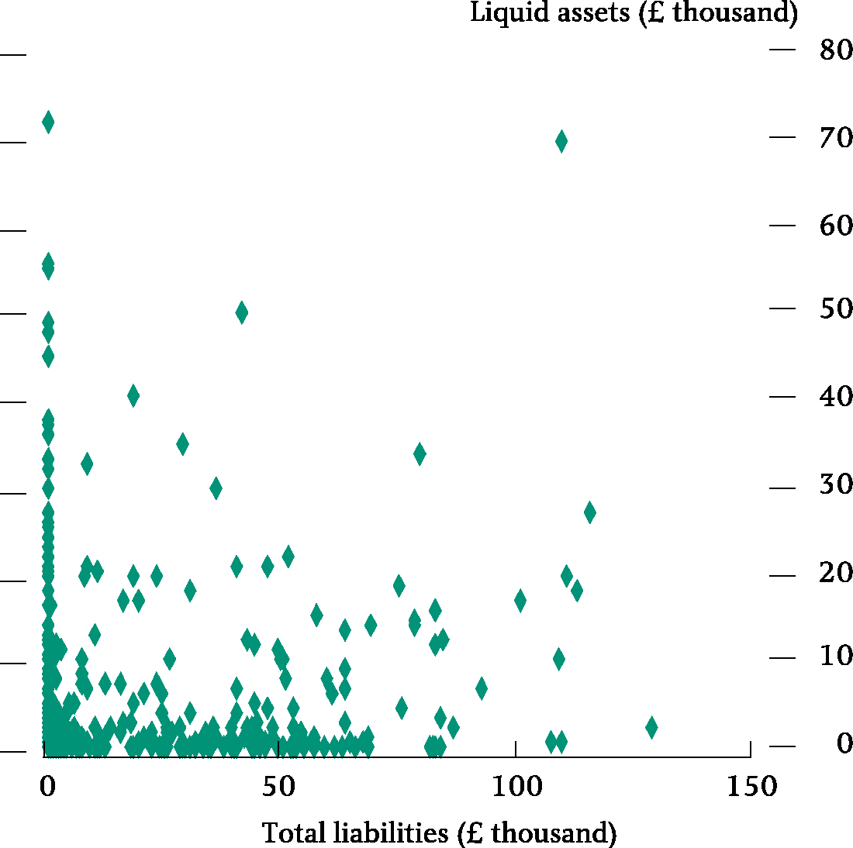

Source: British Household Panel Survey, 2000.

* 1. The full BHPS survey for 2000 contains information on the total liabilities and the liquid assets of more than 5,000 households. Households in the upper percentile of either the liquid assets or the total liabilities distribution were removed. This chart is based on a random 10% sample of the remaining households, with each dot representing one of those households.